How to share a Google Calendar:
- Access your Google Calendar.
- On the upper right, click on the Settings button.
- Select Settings
- Click on the Calendars option at the top of the screen (outlined in red below). 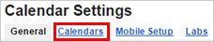
- Click on the name of the calendar you would like to embed.
- Select the Share this Calendar option at the top of the screen.
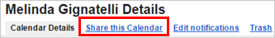
- Under the Share this Calendar with Others settings the “Share this calendar with everyone in the organization East Aurora UFSD” option is selected. Change the setting to “Make this calendar public” and select “See all event details” from the drop down.
- Click Save.

How to generate embed code for a Google Calendar:
- Access your Google Calendar.
- On the upper right, click on the Settings button.
- Select Settings
- Click on the Calendars option at the top of the screen (outlined in red below).
- Click on the name of the calendar you would like to embed.
- Look for the Embed this Calendar option about half way down the page.
- Click on the Customize the color, size, and other options link.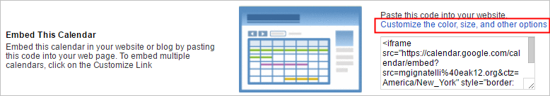
- On the left side of the page you can customize the embed options. Adjust the width to a maximum of 660 (that is the max width of a page on your website). Change any other setting you desire.
- The embed code is at the top of the page. Select all embed code and copy to your clipboard.
- Navigate to your website to add the embed code into an embed code page type.

